**AutoFrame 1.0**

Modified Selenium WebDriver framework

**Major Changes**

1. Reduced data redundancy
2. Removed redundant functions
3. Removed unnecessary files
4. Enhanced source code commenting
5. Removed the project name dependency
6. Email configurations are moved into **config.properties**

**Configuring AutoFrame 1.0 for a new project**

1. **Browser & Execution**

For configuring the Browser and execution features, Go to the config.properties and under the **Browser & Execution** area modify the properties as the requirement.

1. **testsiteBaseURL**

Set the URL of the testing website

1. **browserType**

Set the browser type. eg: Mozilla, Chrome, IE

1. **implicitWait**

Set the implicit wait for the execution in seconds

1. **Backup information**

The framework has the functionality of automatic backup. It will take the backup files of the executing spreadsheets in the backup folder before each execution.

This is done to avoid loss of data in case the excel sheets gets corrupted during execution. The following properties of the backup feature are configurable. (Leave the values as it is recommended)

1. **BACK_UP_PATH**

Go to the constants.java and change the above constant for customising the backup folder

1. **xlsBackupLimit**

Go to config.properties and change the property for changing the number of backups needed at a time

1. **HTML Reporting**

AutoFrame 1.0 has enhanced HTML Reporting features. For customising the HTML Reporting go to the config.properties and change the values of the following properties under the Html Reporting Section

1. **reportFileName**

Set the filename for compressed HTML reports folder. Later this file will be sent through email

1. **reportsHeading**

Set the title of the HTML Reports index.html page

1. **reportsFolder**

Set the folder name for the HTML Reports

Also go to the Constants.java for changing the Constants values under the HTML Reports section

1. **REPORTS_OVERRIDE**

If this boolean constant set ‘**true**’ then, Reports folder content will be overridden with the latest one after each and every execution. If it is set ‘**false**’ then Reports folder will contain sub folders of the reports after each execution.

1. **REPORTS_MAIL**

Set this constant as ‘**true**’ for sending the compressed reports after the execution

1. **Email configuration**

For using emailing feature of the frame work the user need to configure the following properties under the Email Configuration section in the config.properties after setting the **REPORTS_MAIL** constant as ‘**true**’

1. **userName**

Set the host email id

1. **password**

Set the host user password

1. **emailRecipient**

Set the recipient email id

1. **hostName**

Set the hostname. eg : smtp.gmail.com (default)

1. **portNumber**

Set the port number. eg: 465 (default)

1. **subject**

Set the subject of the email

1. **attachmentName**

Set the Reports attachment name with the file extension. eg : Reports.zip

1. **Test data management**

There are two ways to specify the test data for a test case

1. **In the same workbook where the test step for the test case lies**

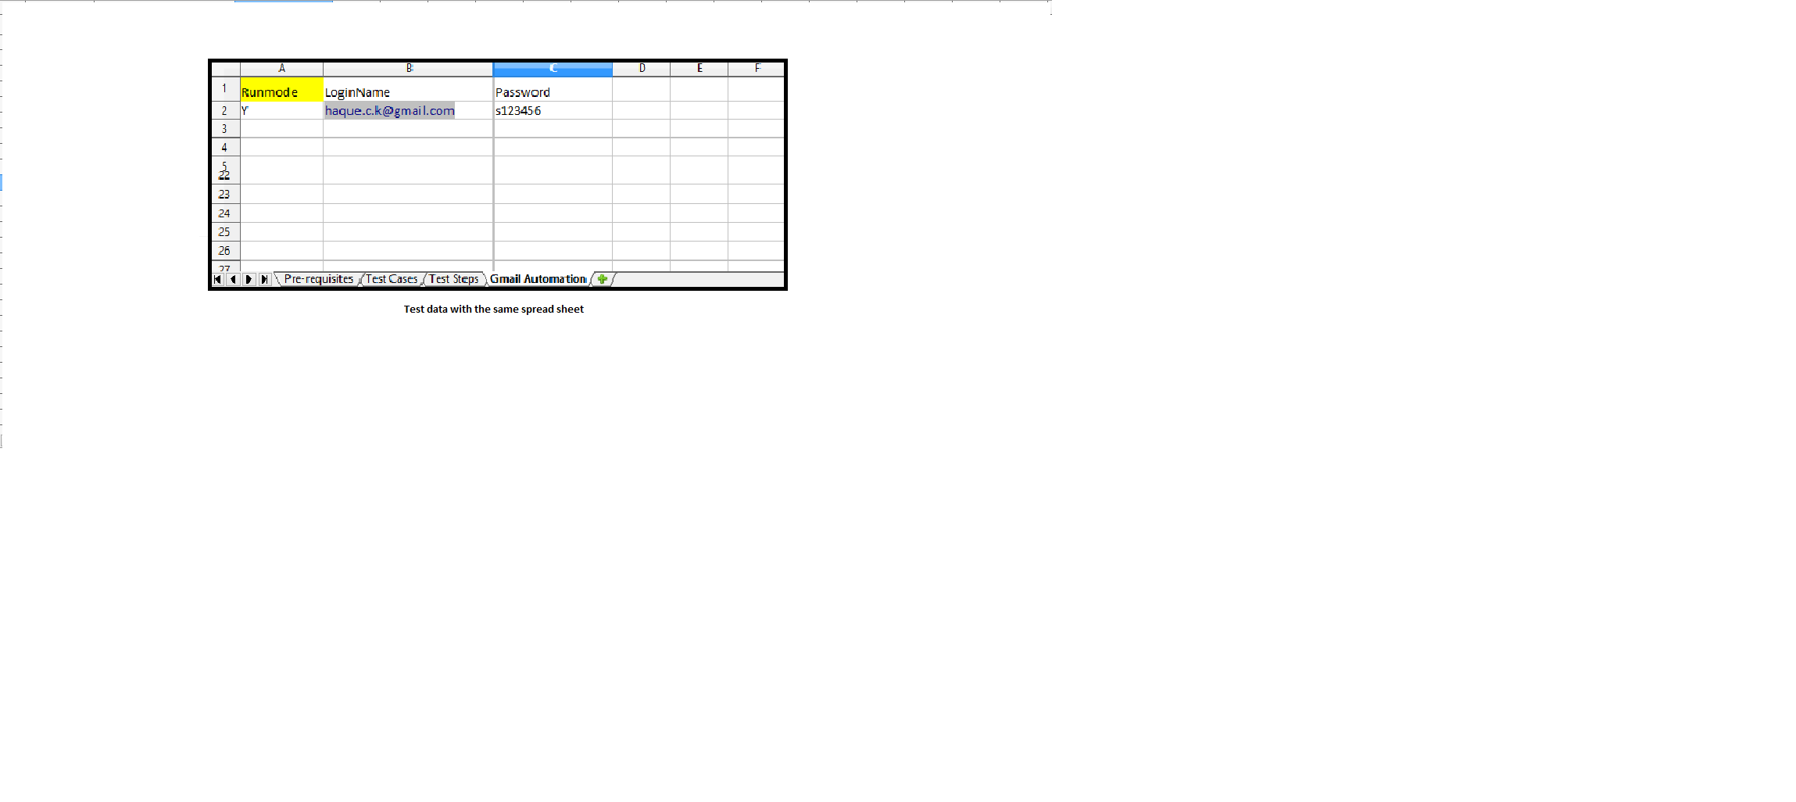

1. **In a Consolidated test data sheet where all the test data lies for a test suite** 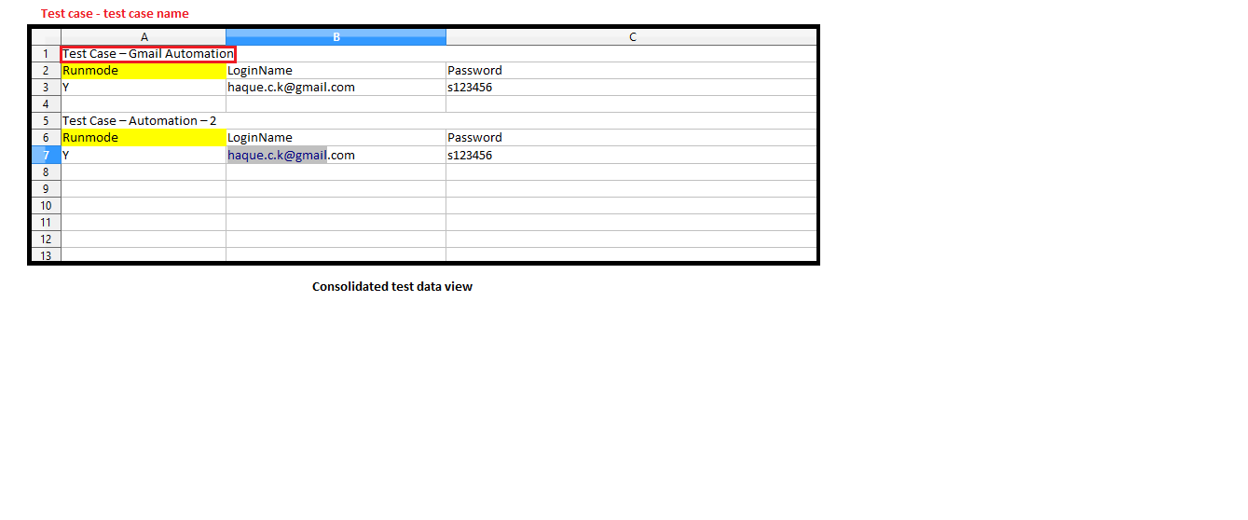

The user has the freedom of choosing which way to follow. That is user can either chose the consolidated method or the earlier one and the AutoFrame 1.0 itself switch the mode of the execution smartly.

However if user want provide the test data in the consolidated test data sheet , then The consolidated data sheet name should be specified in the 1st row, second column of the ‘**Pre-requisites**’ tab of the test case suite spreadsheet.

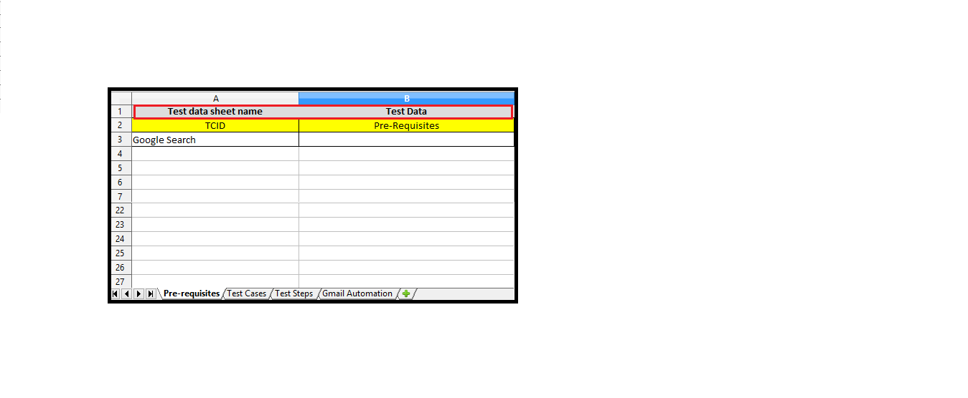

User can configure the consolidated test data constants by going to the Consolidated Test Data section of the Constants.java (Leave the values as it is recommended)

1. **CONSOLIDATED_DATA_FOLDER**

Set the Consolidated data sheet folder path

1. **CONSOLIDATED_DATA_COL**

Set the column number, where consolidated test data sheet name is specified

1. **CONSOLIDATED_DATA_ROW**

Set the row number, where consolidated test data sheet name is specified

1. **CONSOLIDATED_DATA_SHEET_NAME**

Set the inner sheet name where the test data specified in the consolidated test data spreadsheet

1. **CONSOLIDATED_DATA_TAB**

Set the tab name of the test case suite, where consolidated test data sheet name specified.

1. **Testlink Integration**

AutoFrame 1.0 also including Testlink features. For enabling the features user need to change the boolean constant **TEST_LINK_INTGRT** into ‘**true**’in the Constants.java. Also user has to provide the following properties in the config.properties.

1. **devKey**

Set development key of the testlink

1. **serverURL**

Set the server url

1. **projectName**

Set the project name

1. **planName**

Set the plan name of the project

1. **buildName**

Set the build name where the automation test cases are lying

User also need to include a ‘**Mapped TCID’** column in the ‘**Test Cases**’ tab of the spreadsheet where test are included.

And the **Mapped TCID** of a particular test case should be same as the ID in the **Test Specification** of that test case in **Testlink**

